Reports:
Industrial and Trade High School, Slavonski Brod, Croatia
Report- october
1. Project corner- students and teacher Marijana Zarožinski
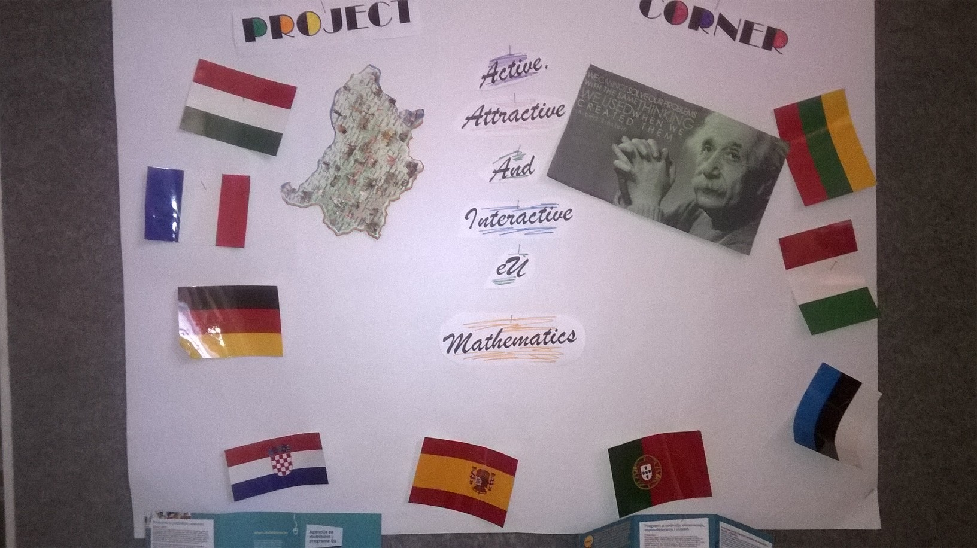
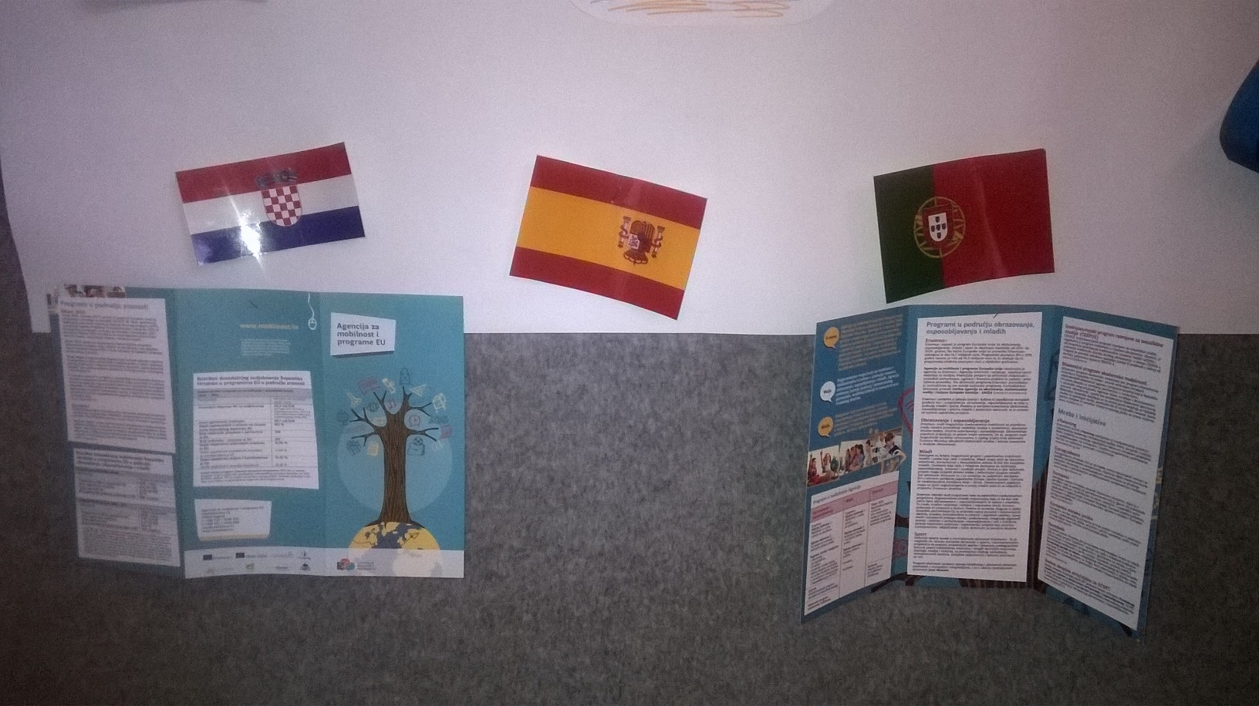
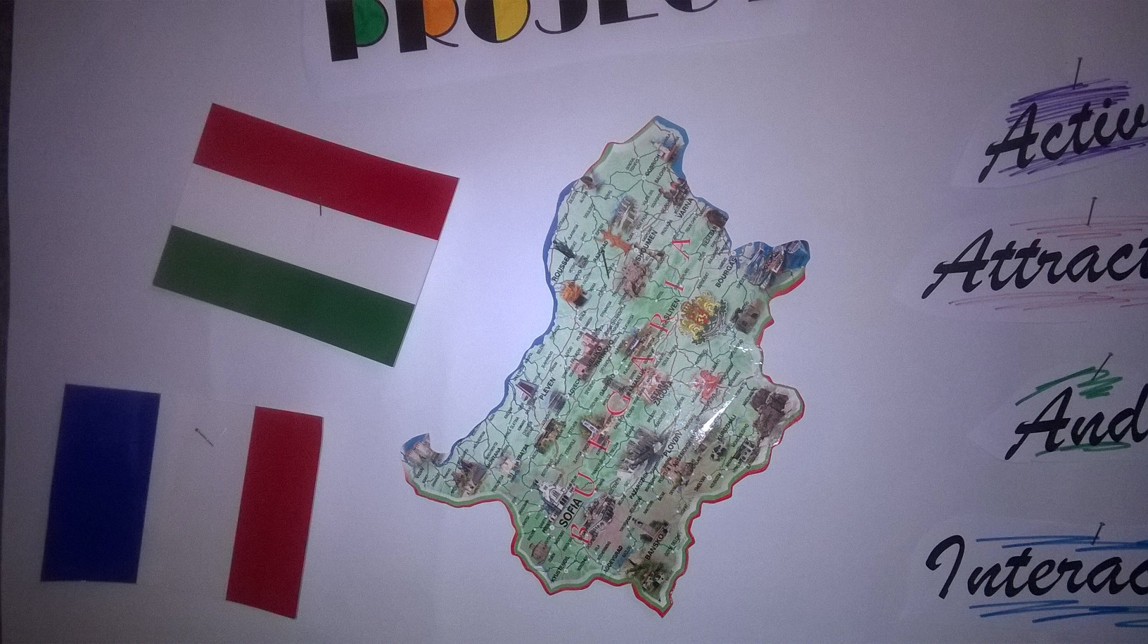2. 25.10. in our school was the Maths Night and presentation of the project to students (170 students are informed during that night)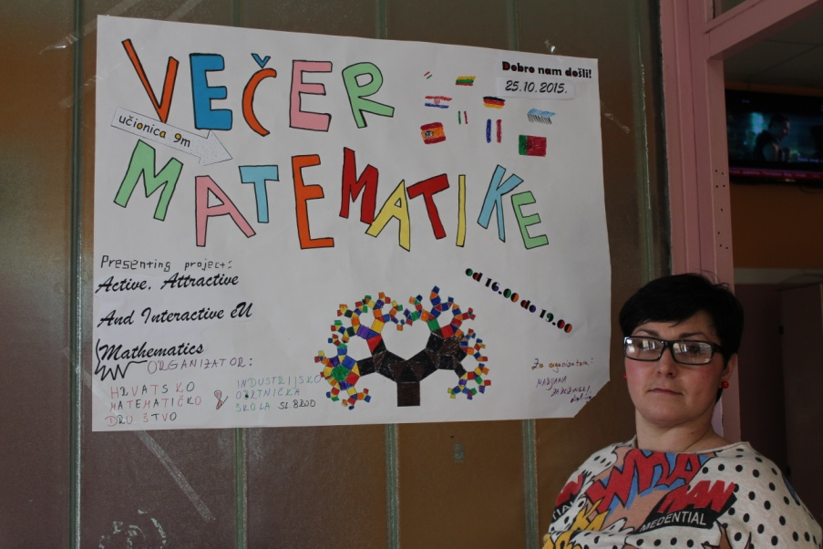
List of students
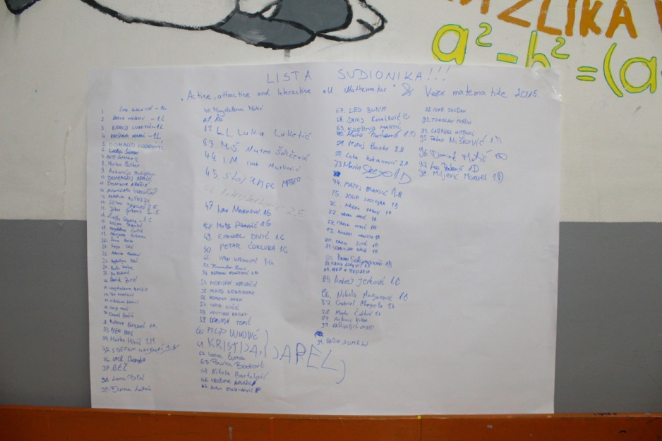
Prezi about project
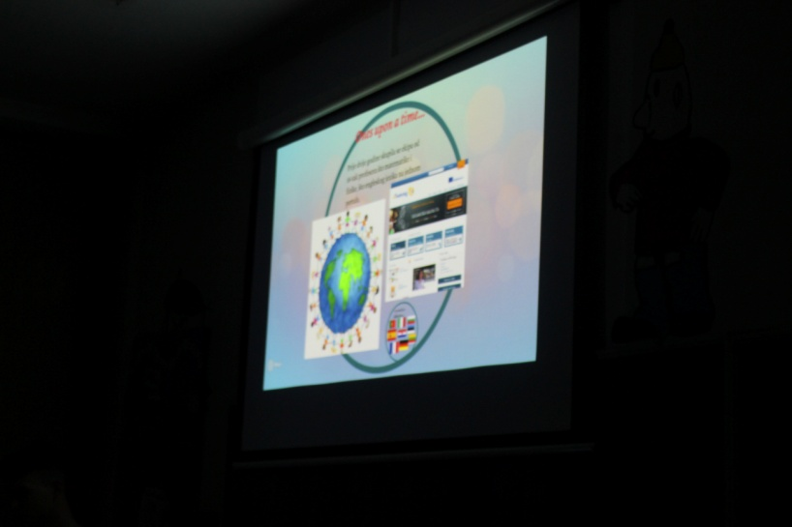
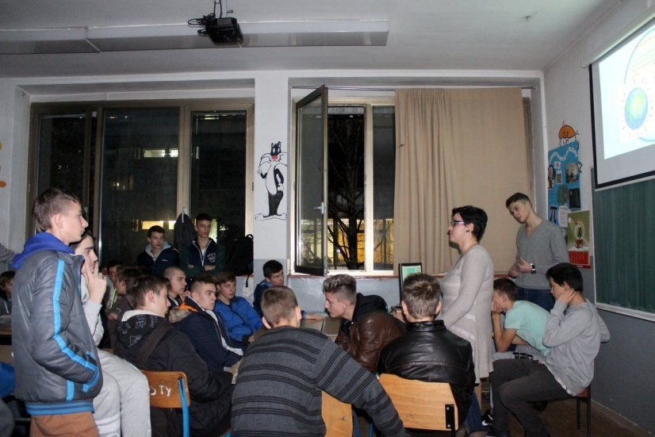

Report- November
1. -Creating You Tube channel
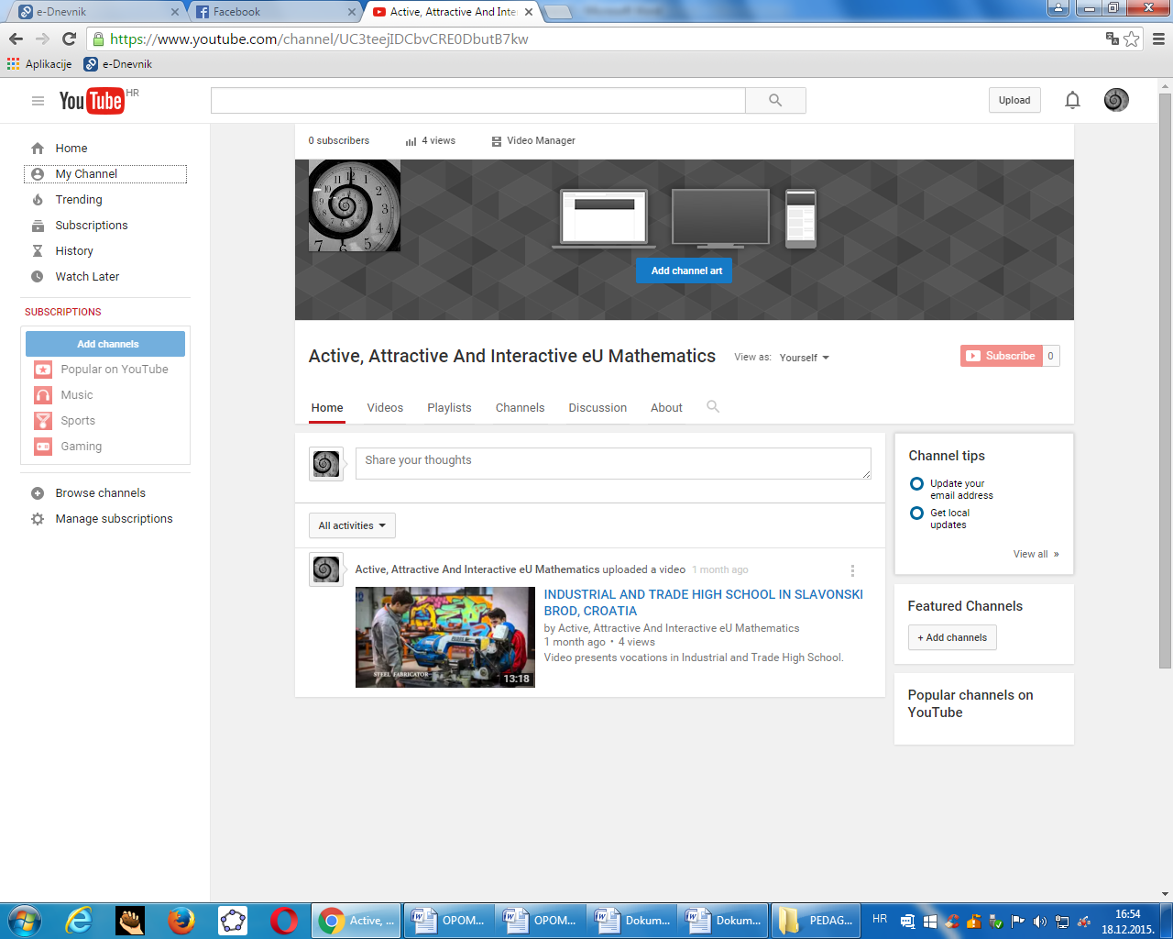
2. Colecting photos from all partners about 1. Meeting
3. Creating album in photo shop with students in vocational training-photographer leed by teachers Antonia i Tomislav Margeta( phoshop and movie maker)
4. Define project team:
Coordinator, suporting, contacts, teacher reasers- 10 in total.
-Defining tasks for each member of project team in our school
Report-december

1. - 9.12. presenting project to the school staff- invitation for school staff meeting
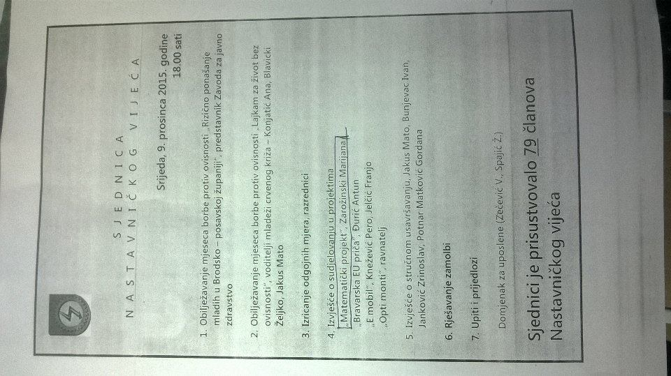
2.
15.12.2015.-new project corner
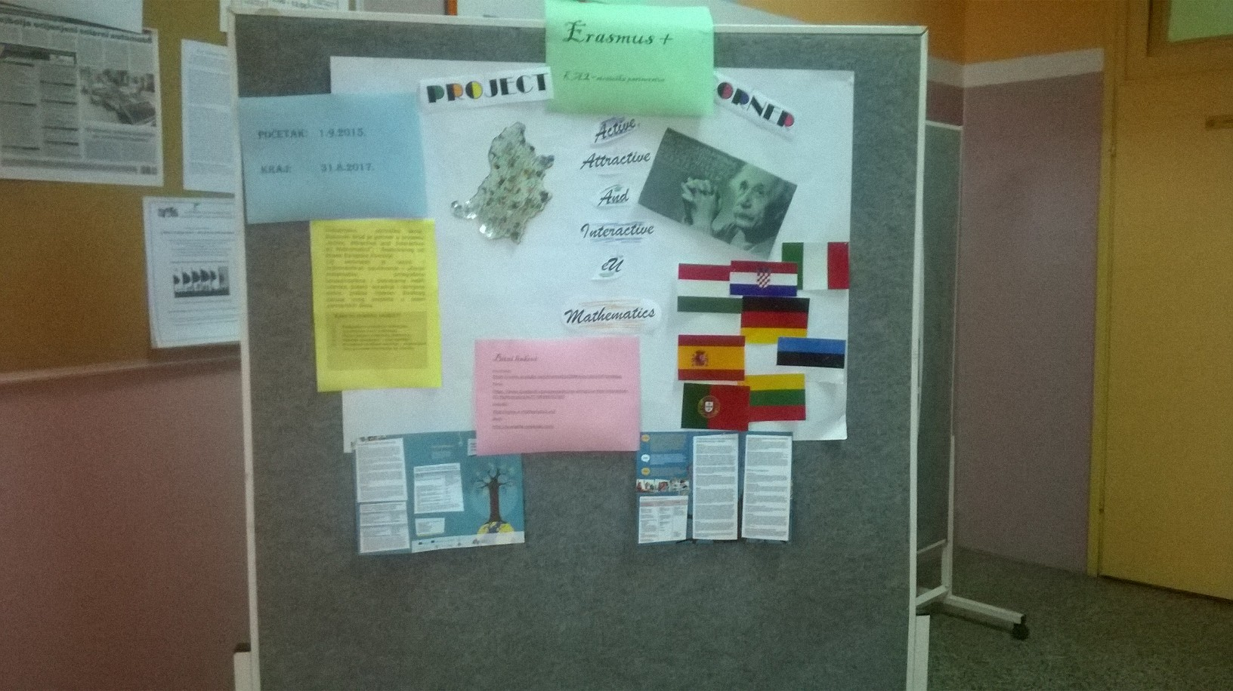
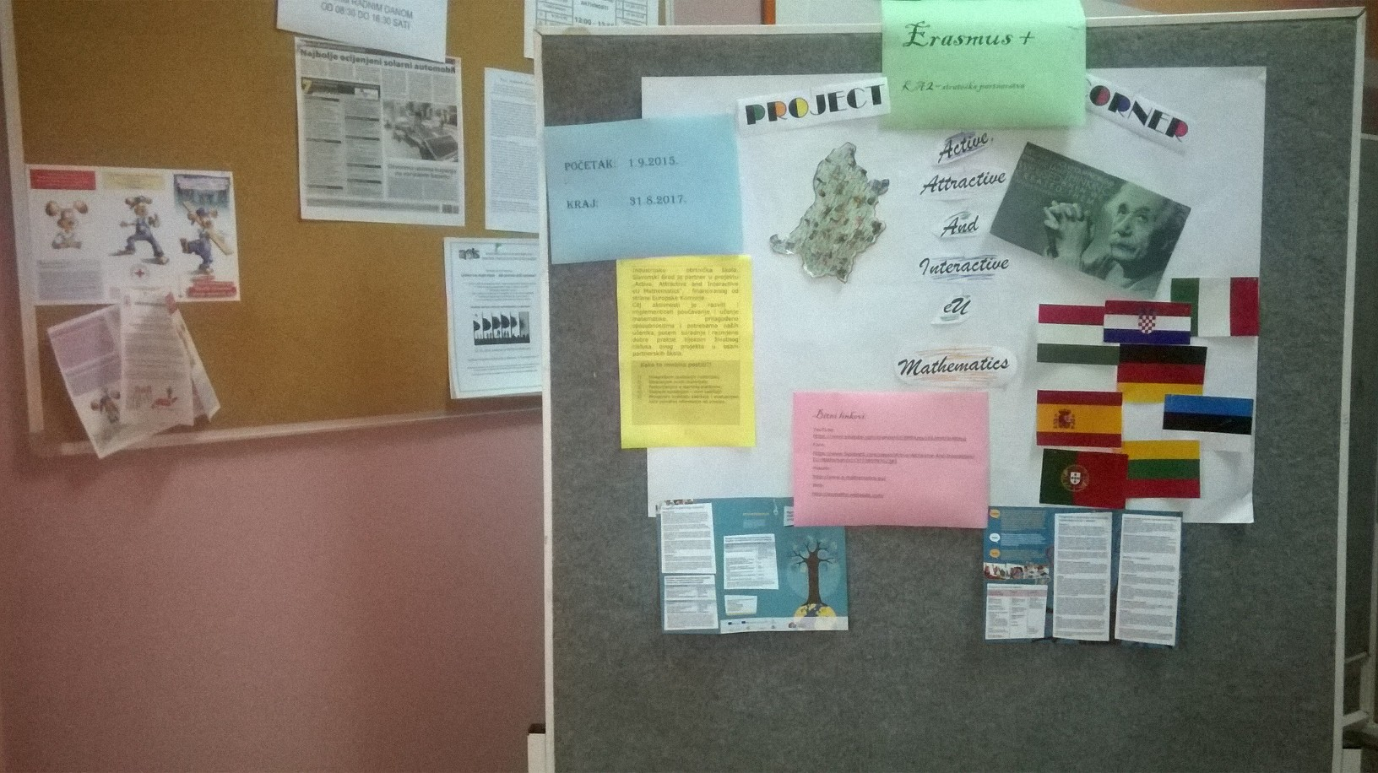
3. 28.12. meeting the school project team 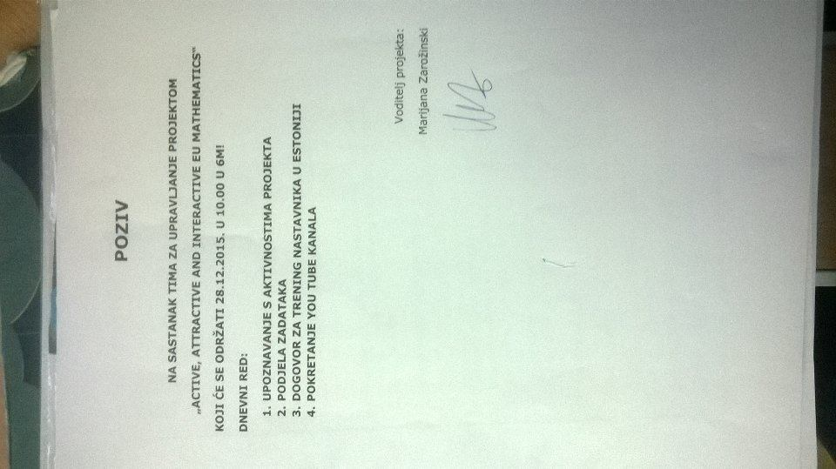
4. You Tube channel launched
5. Article on school web site

Report -January
1. Meetinig of teachers who are going to Estonia
2. Preparing materials, presentations for teacher trainning
3. 22.1.interview on radio station Radio 92- presenting project
Report- february
1. Tacher trainning
2. 26.2. interwiev on radio station Radio 92- about teacher trainning
3. Disemination to school leaders and school stuff
4. Disemination to Agency for education, department mathematics by email
5. Coleting materials for you tube

