Monthly Report

Prepared by Gil Nunes

January 2016

Activity information
Activity Title | Active, Attractive And Interactive eU Mathematics in TwinSpace
Goal | Create a TwinSpace project
Short description | Working on TwinSpace, after approval of the project on January 8 by the Portuguese National Service Support.
Adress | https://twinspace.etwinning.net/16296
Involved | Gil Nunes and Jürgen Mehler
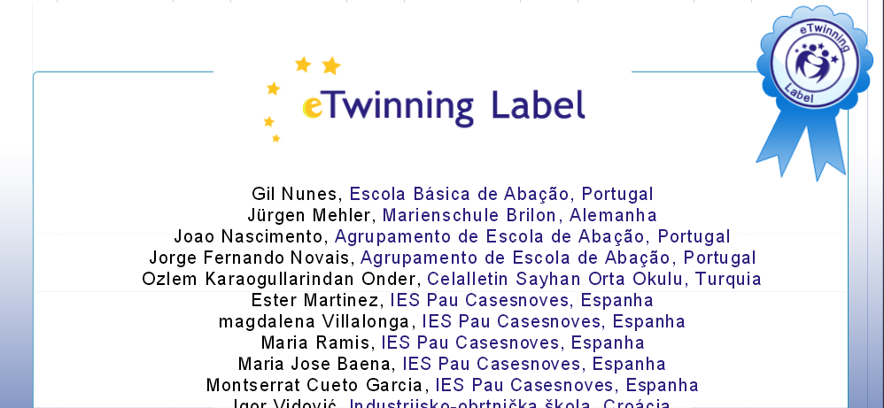

Activity information
Activity Title | Preparation of the short-term joint staff training
Goal | Presentation of the Portuguese curriculum of mathematics and the first lesson plan
Short description | Preparation of Prezzi presentations and lesson plan
Involved | Agostinho Lopes, Isabel Rodrigues, João Nascimento and Jorge Novais
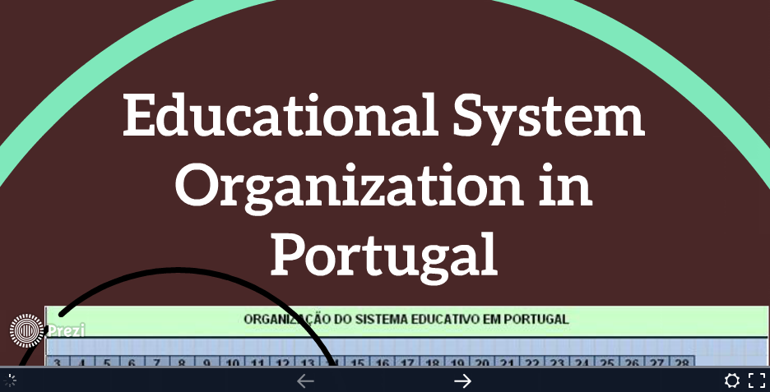

February 2016

Activity information
Activity Title | Short-term joint staff training in Estonia
Goal | Training activity
Short description | The participating teachers were involved in various activities, closely linked to the partnership goals, such as workshops, training on e-learning platforms, exchange of experience and good practice, discussions on teaching based on internet.
Involved | Agostinho Lopes, Isabel Rodrigues, João Nascimento and Jorge Novais
Start and end dates | 14 to 20 February
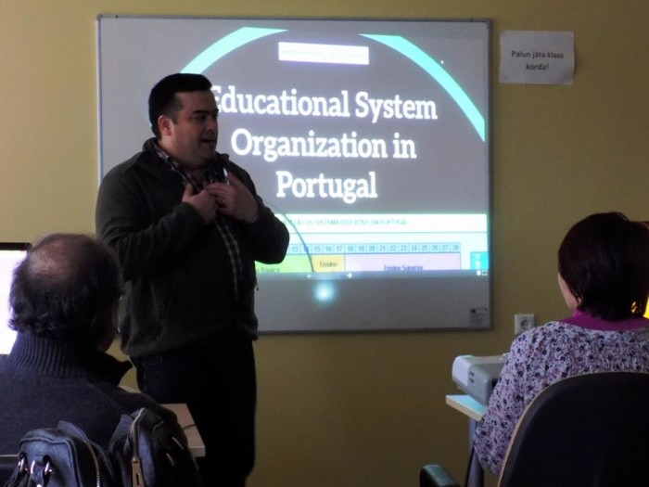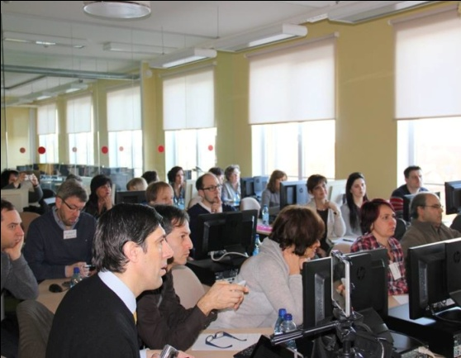

March
Activity Title | Active, Attractive And Interactive eU Mathematics in TwinSpace
Goal | Update the TwinSpace project
Short description | Organization of photos, videos, logos, diary pages and presentations in TwinSpace.
Adress | https://twinspace.etwinning.net/16296
Involved | Gil Nunes and Jürgen Mehler
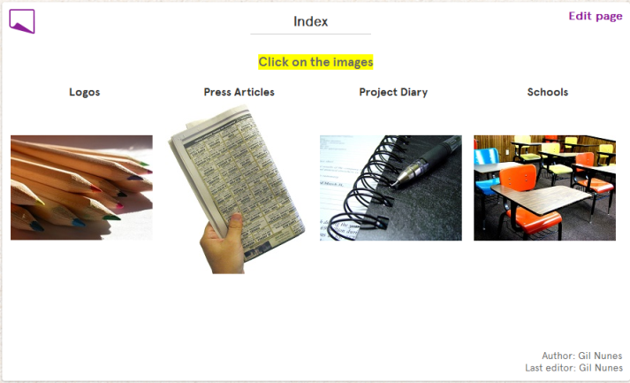

Activity information
Activity Title | SuperT
Goal | Promoting educational success
Short description | The annual Mental Math International Championship is a Mathematics competition for students aged between 6 and 15 years. The competition promotes interest in mental Mathematics and develops skills in number and mental calculations. It aims at reinforcing the learning of Mathematics through constructive play.
Involved | Germana Guedes, Isabel Dias, Isabel Rodrigues and Jorge Novais
Date | March 18
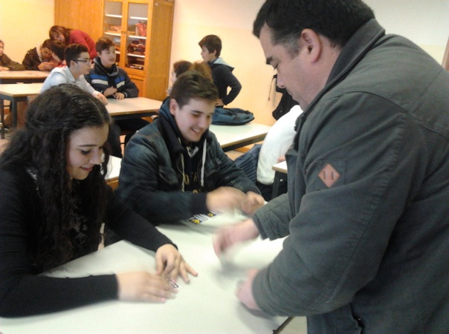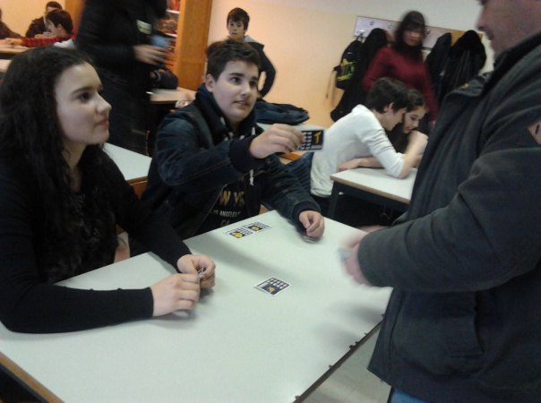

Activity information
Activity Title | School news
Goal | Project dissemination
Short description | Escola Básica de Abação was once again motive of an article in the newspaper Mais Guimarães due to its participation in the project “Active, Attractive And Interactive eU Mathematics”.
Involved | Gil Nunes
Date | March 22
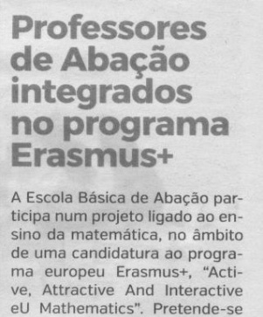

April

Activity information
Activity Title | Second transnational meeting in Lekciai, Lituania
Goal | Evaluation of the activities
Short description | Team's consolidation; 1st version of the teaching/learning materials and the e-learning platform; monitoring of the project's development towards the objectives; monitoring of budget and financial procedures; revision of work plans; preparation of the interim report.
Involved | Gil Nunes, Florbela Salazar and Jorge Novais
Start and end dates | 18 to 21 April
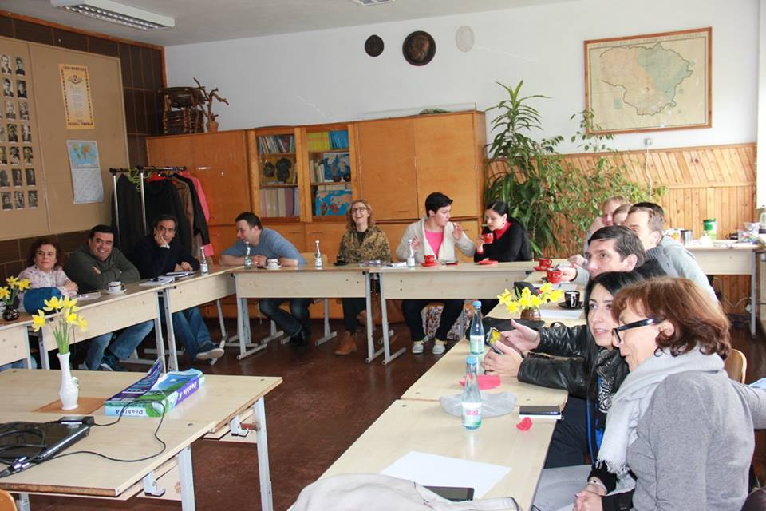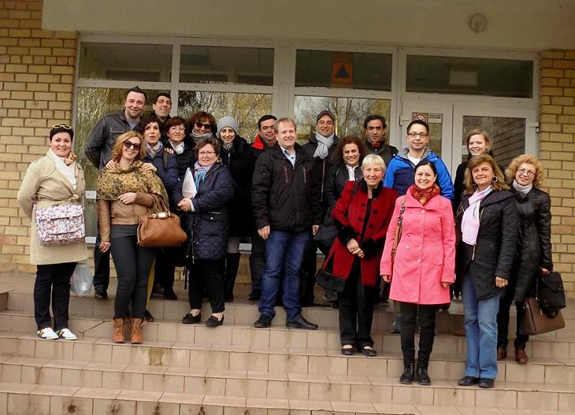

Activity information
Activity Title | It’s time to chat
Goal | Update the TwinSpace project: virtual meetings for students
Short description | Creating a forum in TwinSpace to start the virtual meetings for students.
Adress | https://twinspace.etwinning.net/16296/forums
Involved | Gil Nunes
Date | April 28
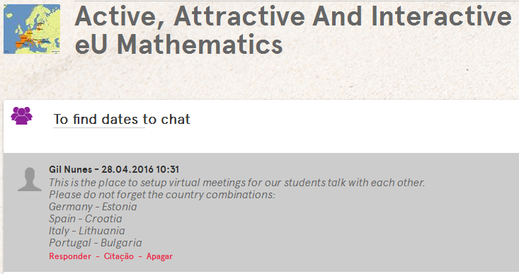

Throughout the school year

Activity information
Activity Title | Project Diary
Goal | Project dissemination
Short description | News about the activities carried out under the project are regularly published at the school site.
Adress | http://agrupamentoabacao.pt/?page_id=2774
Involved | Gil Nunes
