Monthly Report

Prepared by Gil Nunes

September 2015

Activity information
Activity Title | The project’s announcement
Goal | Project dissemination
Short description | The school headmaster, Firmino Lopes, announced the school participation in the project “Active, Attractive And Interactive eU Mathematics” during the first teachers meeting in the beginning of the school year.
Involved | All school teachers
Date | September 3

October 2015

Activity information
Activity Title | Preparation of the first transnational meeting
Goal | School presentation to the other partners
Short description | Preparation of PowerPoint presentations about the school and about Portugal.
Involved | Gil Nunes and Jorge Novais
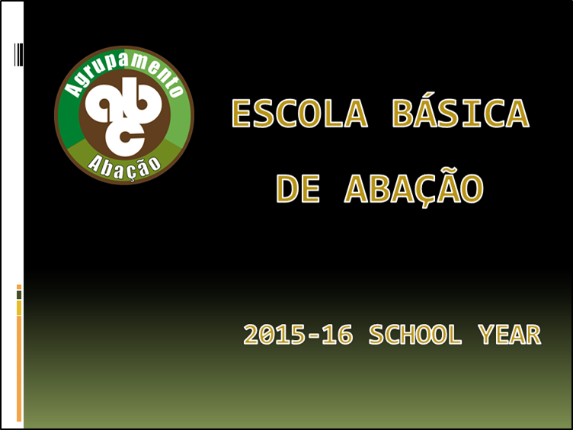

Activity information
Activity Title | First transnational meeting in Bulgaria
Goal | Planning the first year of the project
Short description | Discussions and agreements on work plans, allocation of tasks, deadlines, project management methodology, dissemination plan, evaluation strategy, financial arrangements, etc.
Involved | Gil Nunes and Jorge Novais
Start and end dates | 11 to 16 October
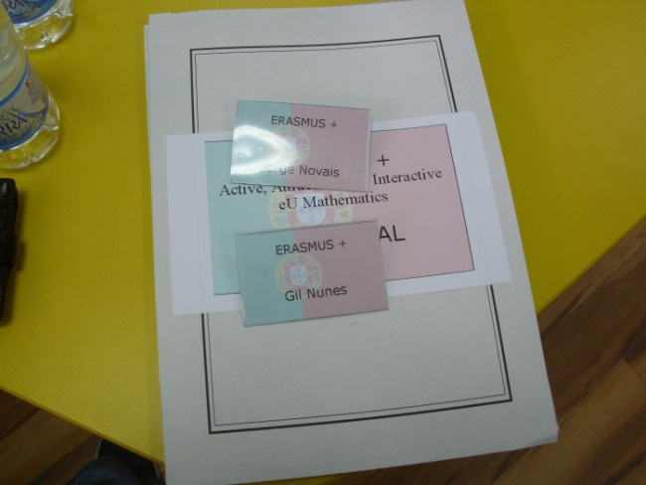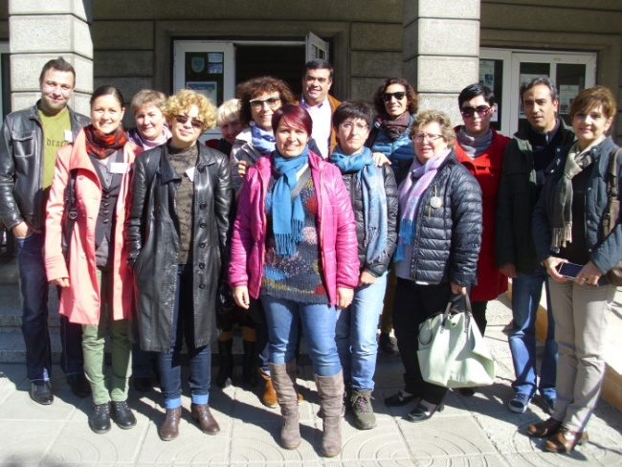

Activity information
Activity Title | School news
Goal | Project dissemination
Short description | Escola Básica de Abação was motive of an article in the newspaper Mais Guimarães due to its participation in the project “Active, Attractive And Interactive eU Mathematics”.
Involved | Gil Nunes
Date | October 27
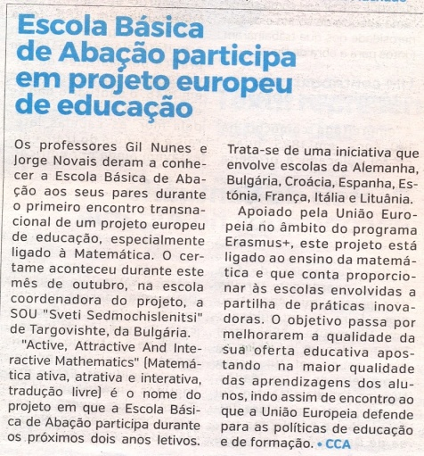

November 2015

Activity information
Activity Title | Ábaco (Abacus)
Goal | Promoting educational success
Short description | Mariana and Jorge built an abacus that enabled the other students in the class to understand the content "addition and subtraction of integers." Now it's easy to solve numerical expressions: (-2) + (- 5) - (- 3) = ...
Involved | Germana Guedes
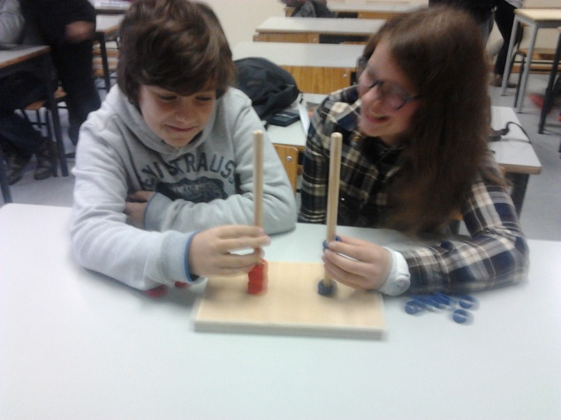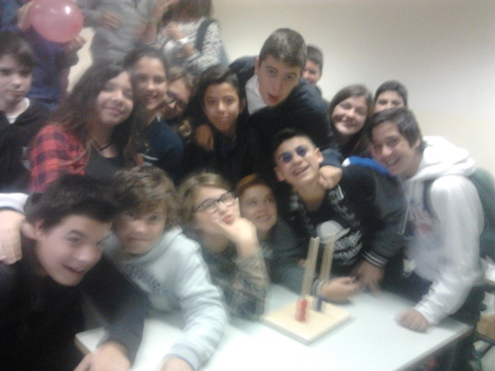

Activity information
Activity Title | To TwinSpace and beyond!
Goal | Involving all project partners in eTwinning and TwinSpace
Short description | Learning how eTwinning and TwinSpace works as a tool for cooperation and communication. Creating a short guide about it.
Involved | Gil Nunes
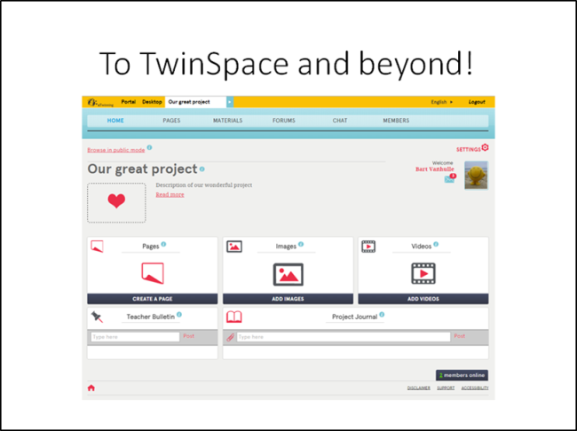

December 2015

Activity information
Activity Title | Active, Attractive And Interactive eU Mathematics in TwinSpace
Goal | Creating a TwinSpace project
Short description | I have been working closely with Jürgen Mehler, our German partner, and the TwinSpace project was presented to the Portuguese National Service Support.
Involved | Gil Nunes and Jürgen Mehler

Activity information
Activity Title | MatBolo (MathCake)
Goal | Promoting educational success
Short description | The maths department teachers organized a competition where students had to make a cake which included some mathematical concepts.
Involved | Germana Guedes, Isabel Dias, Isabel Rodrigues and Jorge Novais
Date | December 18
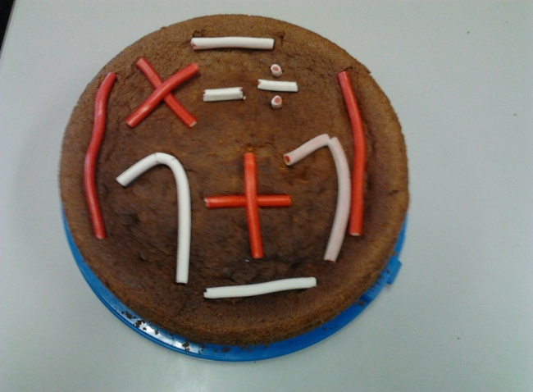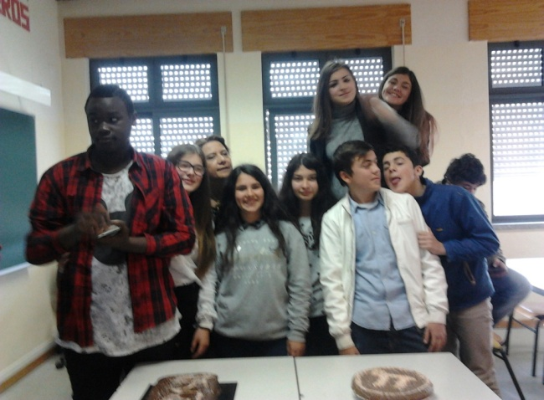

Throughout the school year

Activity information
Activity Title | Project Diary
Goal | Project dissemination
Short description | News about the activities carried out under the project are regularly published at the school site.
Adress | http://agrupamentoabacao.pt/?page_id=2774
Involved | Gil Nunes
