Report
Activities of the German partner in the first project year 2015/2016

- September 2015
- information to the school staff of our school about the project approval, its aims and the first steps to do
- information to the students about the project and the possibilities to take part in projects activities
- The project manager at the school uses Facebook and emails to be in contact with the partners.
- Students create video tutorials about mathematical topics of their last gradein order to repeat them.
Example: http://www.e-mathematics.eu/mod/resource/view.php?id=177
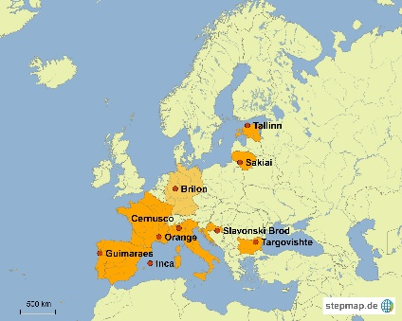
  - Creation of a digital map, showing all partners cities in Europe.

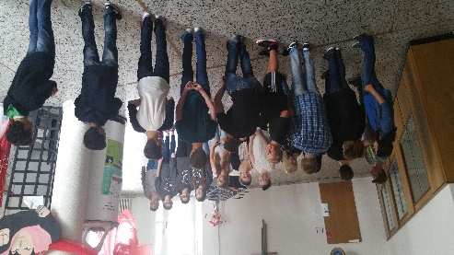
- October 2015
  - Teachers try new, more activating methods in their lessons in order to motivate students.
  - The first transnational meeting in Bulgaria took place during the holidays in Germany, so there is no German delegation in Bulgaria.
  - The project manager get in contact via Skype with the partners at the first transnational meeting in Bulgaria.
  - Information about the results of the first transnational meeting via Facebook and email.
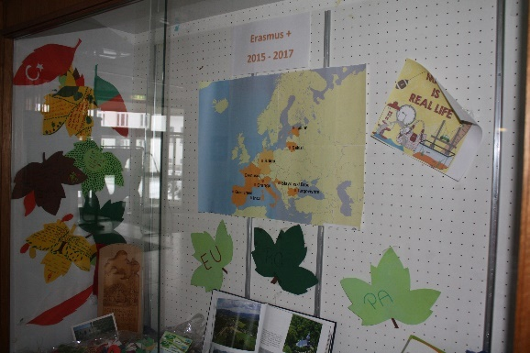
- November 2015
  - Redistribution of tasks after the withdraw of the French team
  - Installation of an Erasmus+ corner at our school.

- December 2015
  - Students learn trigonometrical basics by using a Prezi-presentation created by the project manager:
https://prezi.com/ju1-eq2s52qt/driving-up-the-ski-jump/

  - The project manager at the school uses Facebook and emails to be in contact with the partners.
  - Invitation of two other teachers to join the Facebook group.

- January 2016
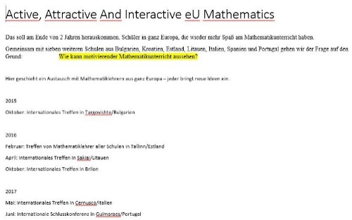
  - Creating of the projects TwinSpace in collaboration with Portugal: https://twinspace.etwinning.net/16296/home

  - Information about the project during the open day at school

  - The project manager at the school uses Facebook and emails to be in contact with the partners.

- February 2016
  - Several meetings of the schools Erasmus group in order to organize the Short Term Joint Staff training - Estonia - 14. - 20.2.2016
  - First initializing in basics of Moodle by a computer science teacher
  - Invitation of a group of students to the TwinSpace
  - Creation of a page on TwinSpace where students can introduce themselves
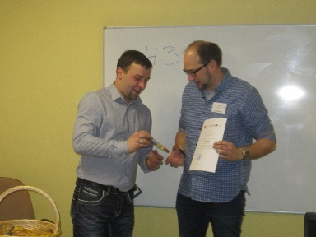
  - Attendance to the “Short Term Joint Staff training - Estonia - 14. - 20.2.2016” of four math teachers: Mr. Michael Stratmann, headmaster, Mr. Jürgen Mehler, deputy headmaster, Mr. Friederic Köhler and Mr. Martin Wieseler, computer science and math teacher.
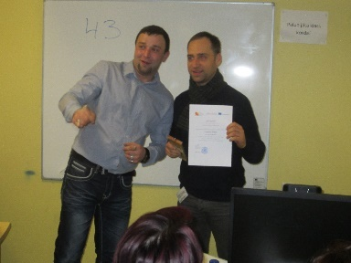
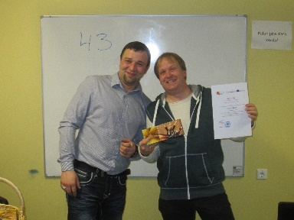
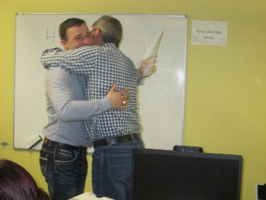
- March 2016
  - Several activities in order to celebrate the Worlds Mathematics Day: Doing quizzes, solving Fermi problems …
  - two meetings of the schools Erasmus group in order to coordinate schools activities
  - The project manager at the school uses Facebook and emails to be in contact with the partners.
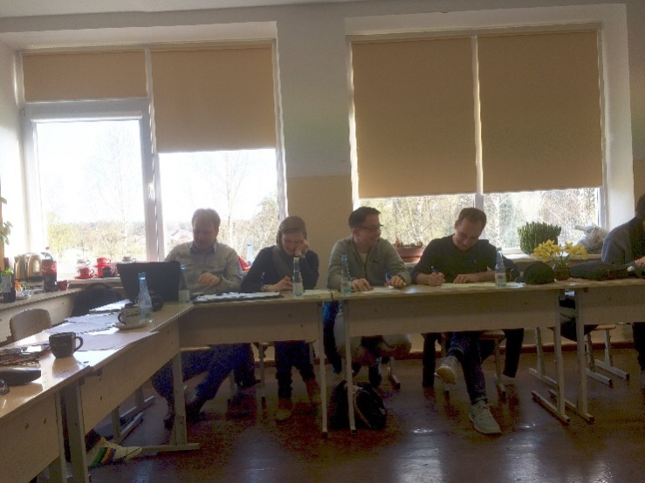
- April 2016
  - Several meetings of the schools Erasmus group in order to organize the second transnational meeting in Lithuania – 18. – 21.4.2016
  - Collecting first ideas and texts for the first newsletter
  - Attendance to the second transnational meeting in Lithuania – 18. – 21.4.2016 of four teachers: Mr. Jürgen Mehler, Mr. Friederic Köhler, Mr. Patrick Baaden and Mrs. Simone Sommer

- Mai 2016

