September 2015
- Announcement of the project approval to the school staff/community.
- Gethering of the Schools Project team and introduction about aims and activities, discussion about the tasks and responsibilities of each member.
- Announcing project to the students- we introduced what project will be going on for next 2 years and decided how and when will we test our produced materials on them.
- Teachers` virtual mobilitiy (eTwinning, FB, Skype, e-mails)
- Preparations for 1st transactional meeting in Bulgaria- preparation of Schools introduction and needed materials for meeting
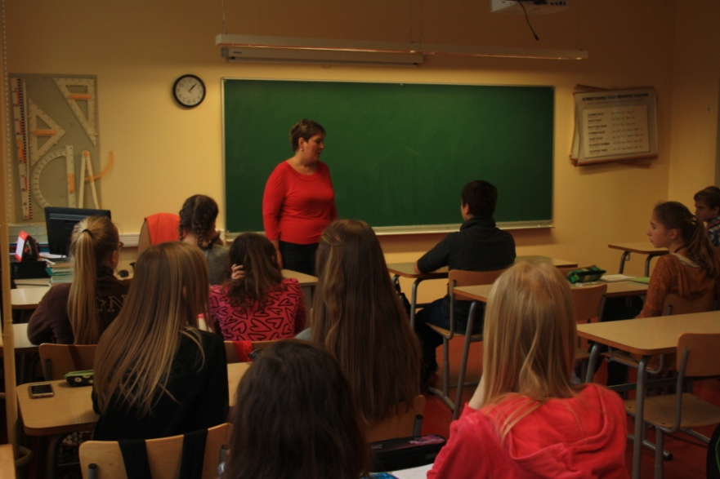

October 2015
- 1st transnational project meeting (Bulgaria) 13th – 15th of October 2015 SOU “Sveti Sedmochislenitsi”
Targovishte, Bulgaria, Participants from Estonia- Anu Reha and Lauri Vilibert
- Project group meeting to introduce information from Bulgaria meeting, explanation of tasks and responsipibilities to members.
- Information sharing to 3rd parties
- Drafts of all major reports and management, implementation, communication and dissemina

November 2015
- Preparation of project corner by students- discussion about participating countries, their location and history, culture and languages.
- Project team meeting, discussion about teachers training in Tallinn
- Online discussions with partners about project

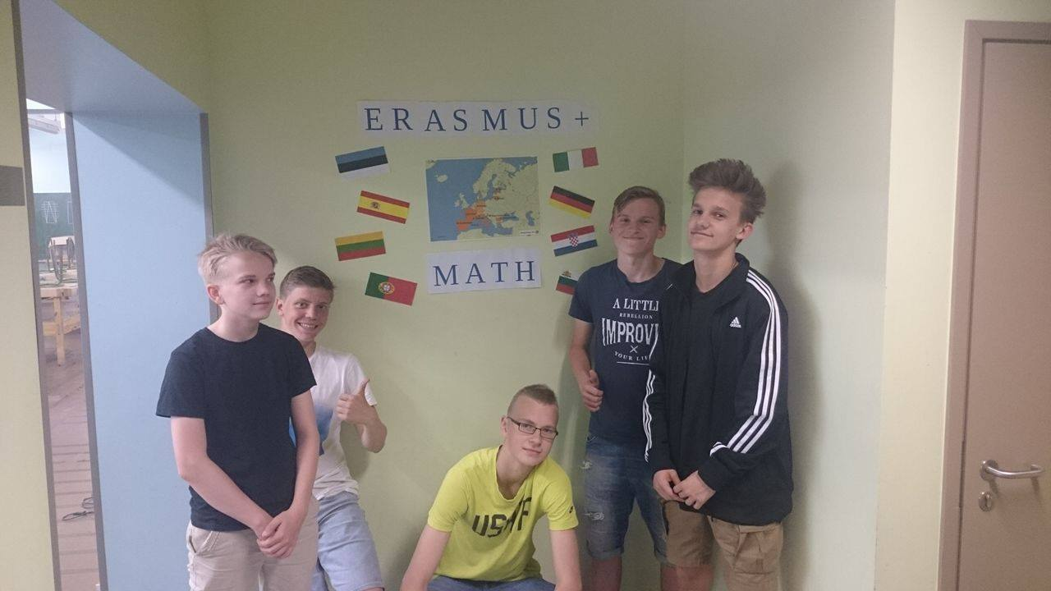

December 2015

- Project team virtual mobility
- Team discussion about lesson plans, about structure, the objectives etc
- Students and teachers discussion about participating countries christmas traditions.
- Preparations to teachers training in Tallinn, responsibilities and tasks to be carried out before teachers training
- Updating the FB page, online discussions
- Monitoring and evaluation of project

January 2016

- Active preparation of teachers training in Tallinn- gathering information about participants, booking and organizing transport, accomondation of quests
- Preparing first draft of activities in teachers training in Tallinn, discussion with partners about teachers training
- Preparing plan for lesson plans
- work on e-platform

February 2016

- Active work on teachers training in Tallinn
- approving the agenda of teachers training
- Transnational short-term joint staff training Estonia, Tallinna Kristiine Gümnaasium 15th February to 19 th February 2016

March 2016

- Selfanalysis of teachers training in Estonia, what went good, what could have more better
- Informing school staff and 3rd parties about the training/ activities and ouputs.
- Celebration of Pi day- updating the project corner, On Pi day we had a fun game- we printed out first 1000 digits of Pi and then started to look for numbers that are in our everyday lives- (birthdates, phonenumbers, aadresses, age etc)- students from one class were able to find 325 different number that correspond to something in their lives
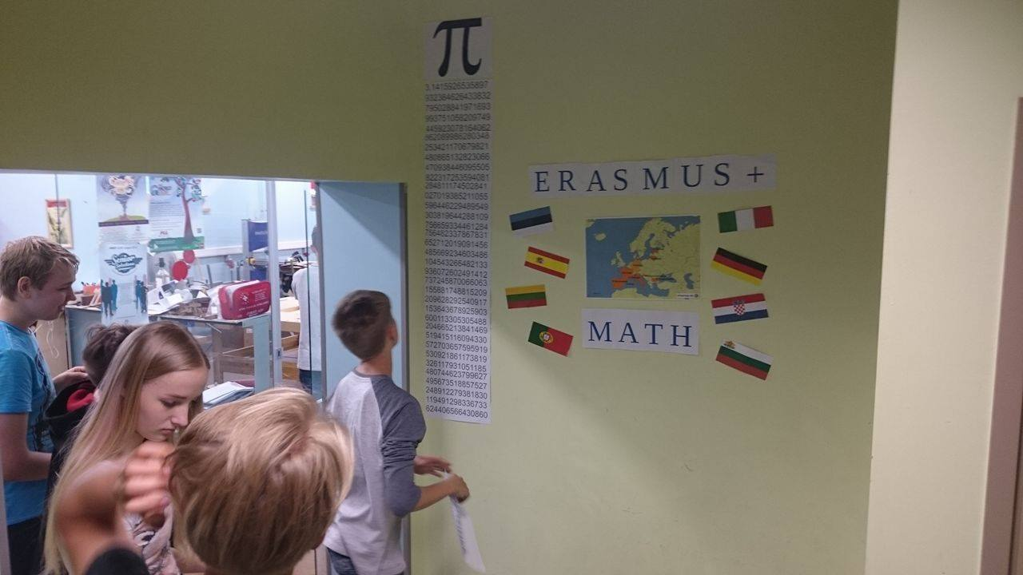

April 2016

- Preparation materials for 2nd transnational meeting
- 2nd Transnational Project Meeting at Lekeciai School from the 18th to the 22nd April, 2016
- Informing school staff and 3rd parties about the activities and ouputs of 2nd transnational meeting.
- Groupdiscussion/mindstorming with older students, creating and gathering ideas on real life math situation that could be implemented into lessonplans so that lessonplans would be interesting and useful
May 2016

- Preparation of lesson plans
- Celebrations about Europe Day, students in groups participated in quiz about Europe countries, their culture ect.
- Virtual mobility and online discussion in Twinspace about math between Estonian and German students
- Monitoring and evaluation

June 2016
- Publishing 1st lessonplans on Moodle
- meeting/colloboration and discussion/desimination seminar to region teachers in the middle of june
- Evaluation of first half year of project team work, tasks and responsibilities.

