REPORT
SEPTEMBER, 2015
- The announcement of the project approval to the school staff/community (30 teachers).
- During the Project’s Information Day,on September 25th, 2015, 130 students and 98 parents wereinformed about the project at the school meeting.
- The project was announced to the Methodical Council (30 teachers) in Sakiai district.
- School project teams were modified. It consists of 5 teachers and 10 students.
- Teachers’ virtual mobility continuously took place on FB, Skype, e-mails). Teachers created the school logo and the material for the project’s website.
OCTOBER, 2015
- Two teachers attended the first transnational meeting in Bulgaria on October 12-16th, 2015.
- Teachers created e-mail lists of stakeholders and interested parties (network of contacts).
- Monitoring and evaluation team created the questionnaire for all partners after the first transnational meeting in order to get relevant information about the quality of the activities.
- The article about the project’s progress in a local newspaper “Valscius”(no.81(2313) appeared on October 27th and the project was presented through social networks and on school website.

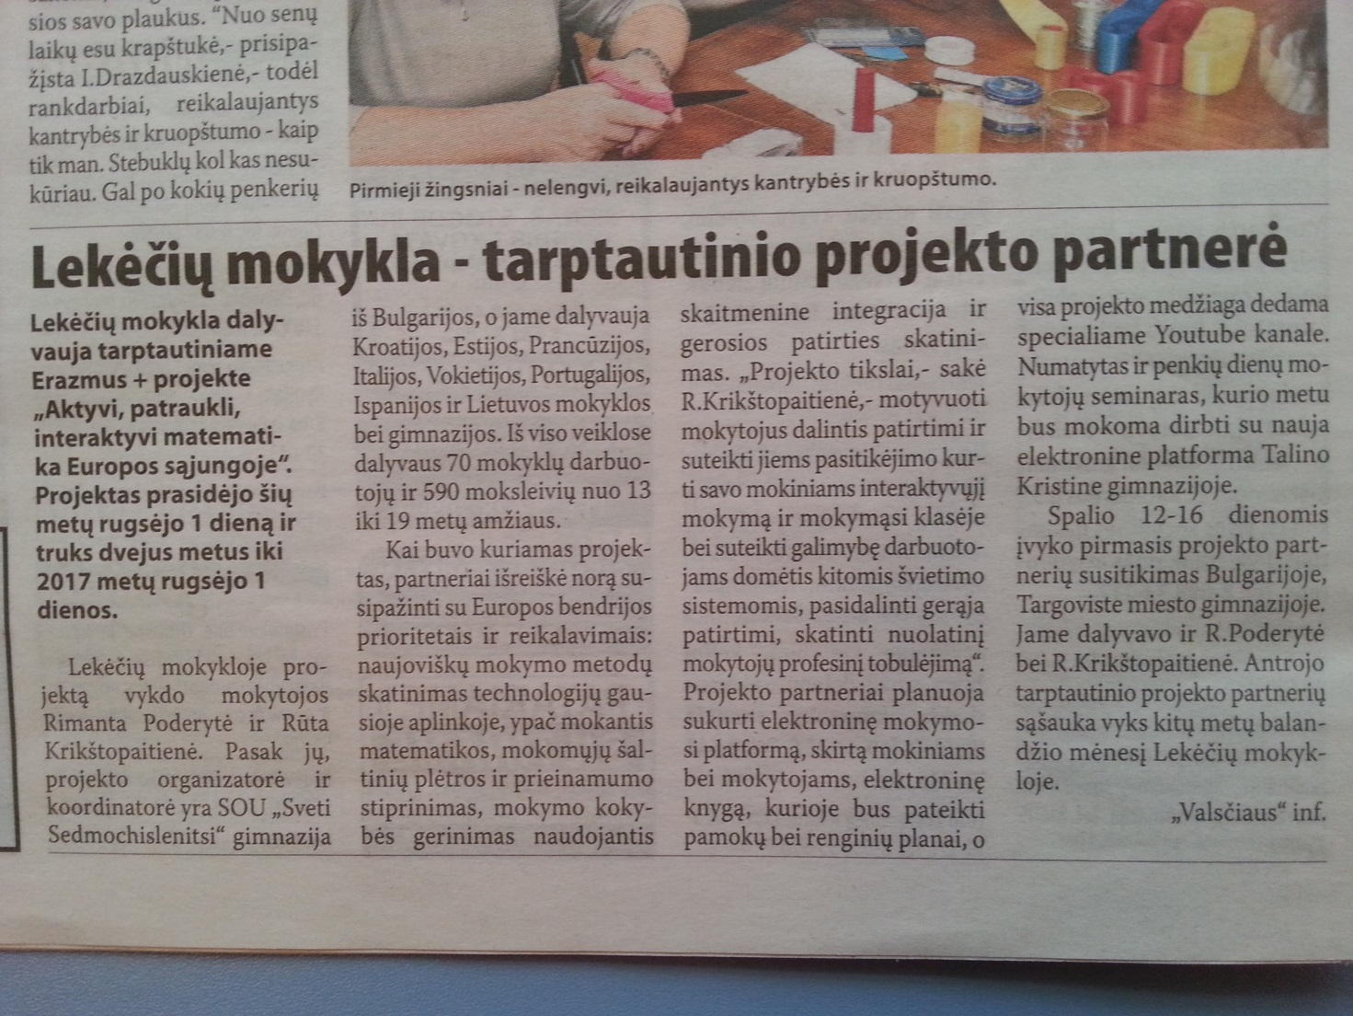

NOVEMBER, 2015
- The Project display board/ Erasmus+ corner was designed in school.
(įterptipaveikslėlį)
- Taking part in a Project‘s website updates and evaluation survey.
DECEMBER, 2015
- Material on the project display board/ Erasmus+ corner was updated.

(įterptifoto)

- Teachers‘ virtual mobility – discussions were about the transnational short-term joint staff training in Estonia.
- Maths teachers created lesson plans and prepared presentations of lesson plans and the Maths‘ programme (different countries curricula).
- Monitoring and evaluation team created the questionnaire for all partners to evaluate the short-term joint staff training in Estonia.
JANUARY, 2016
- Teachers‘ preparation for the short-term joint staff training in Estonia.
- Project‘s Day in school.We presented the project and its progress. Students presented (made presentations) each country participating in the project.
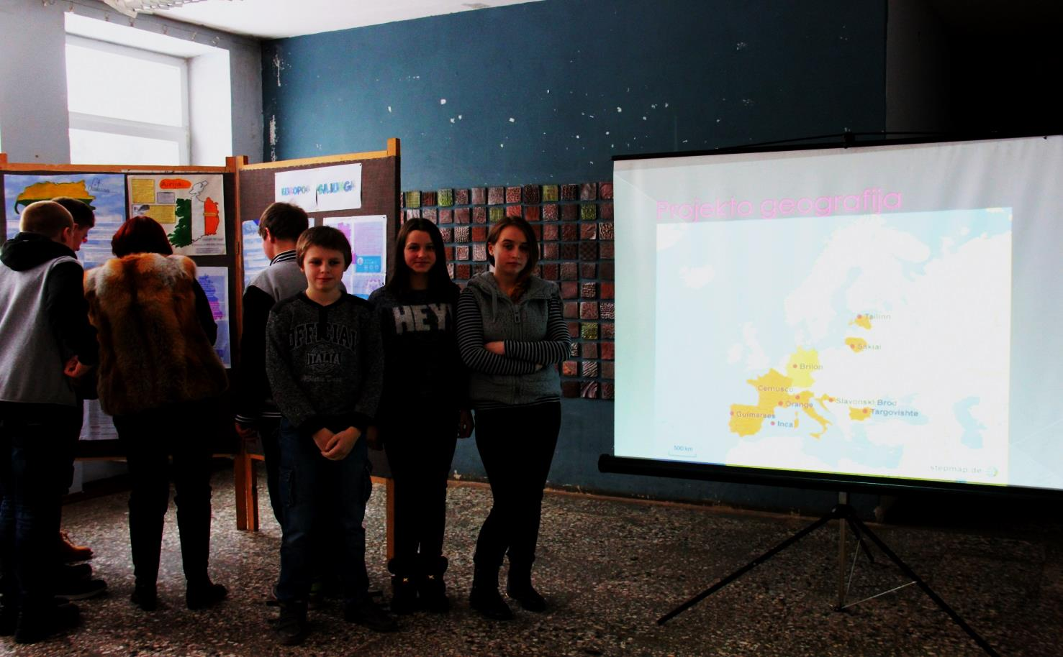
- Discussions with maths teachers and other teachers about web-based teaching and learning and interactive methods in Maths teaching.
FEBRUARY, 2016
- 3 teachers attended the short-term joint staff training in Estonia and shared their experience and good practice at Teaching Mathematics in partner schools.
- Teachers answered the evaluation questionnaire on Google Drive after the teachers‘ training in Estonia.
- The article about the short-term joint staff training in Estonia was published in a local newspaper: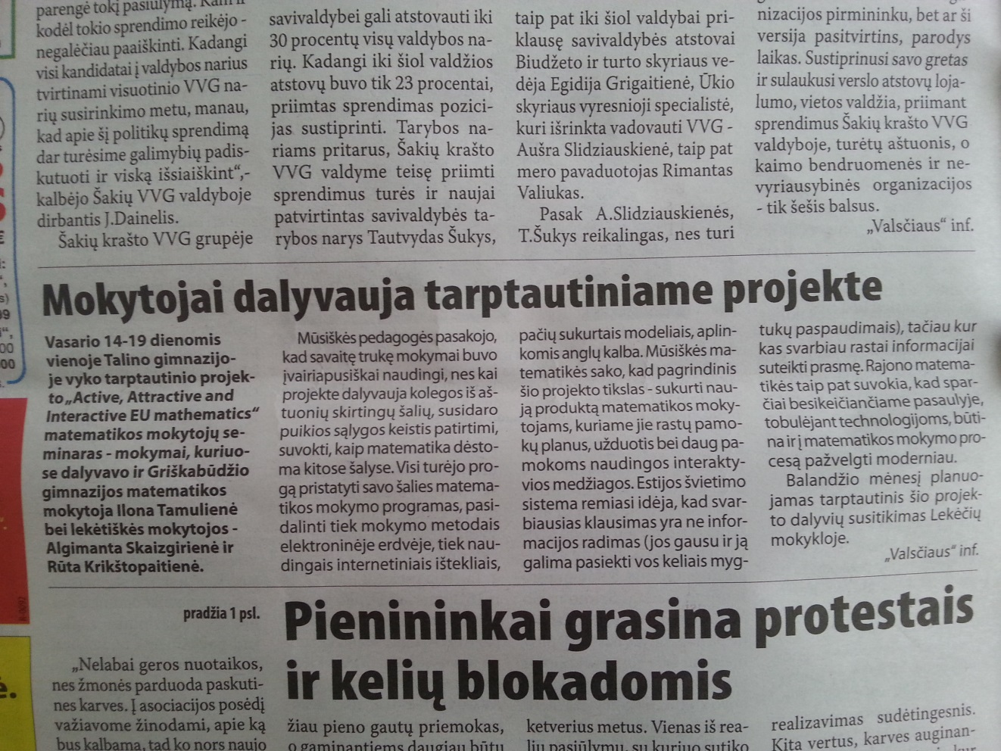 and on school website:http://www.lekeciai.sakiai.lm.lt/

MARCH, 2016
- Creating the scenario and tasks for the Mathematics Day competition at school.
- Mathematics Day was a public event for school staff/ community. 10 teachers, 30 students (participants of the competition) and other 150 school staff/ community members attended the event.
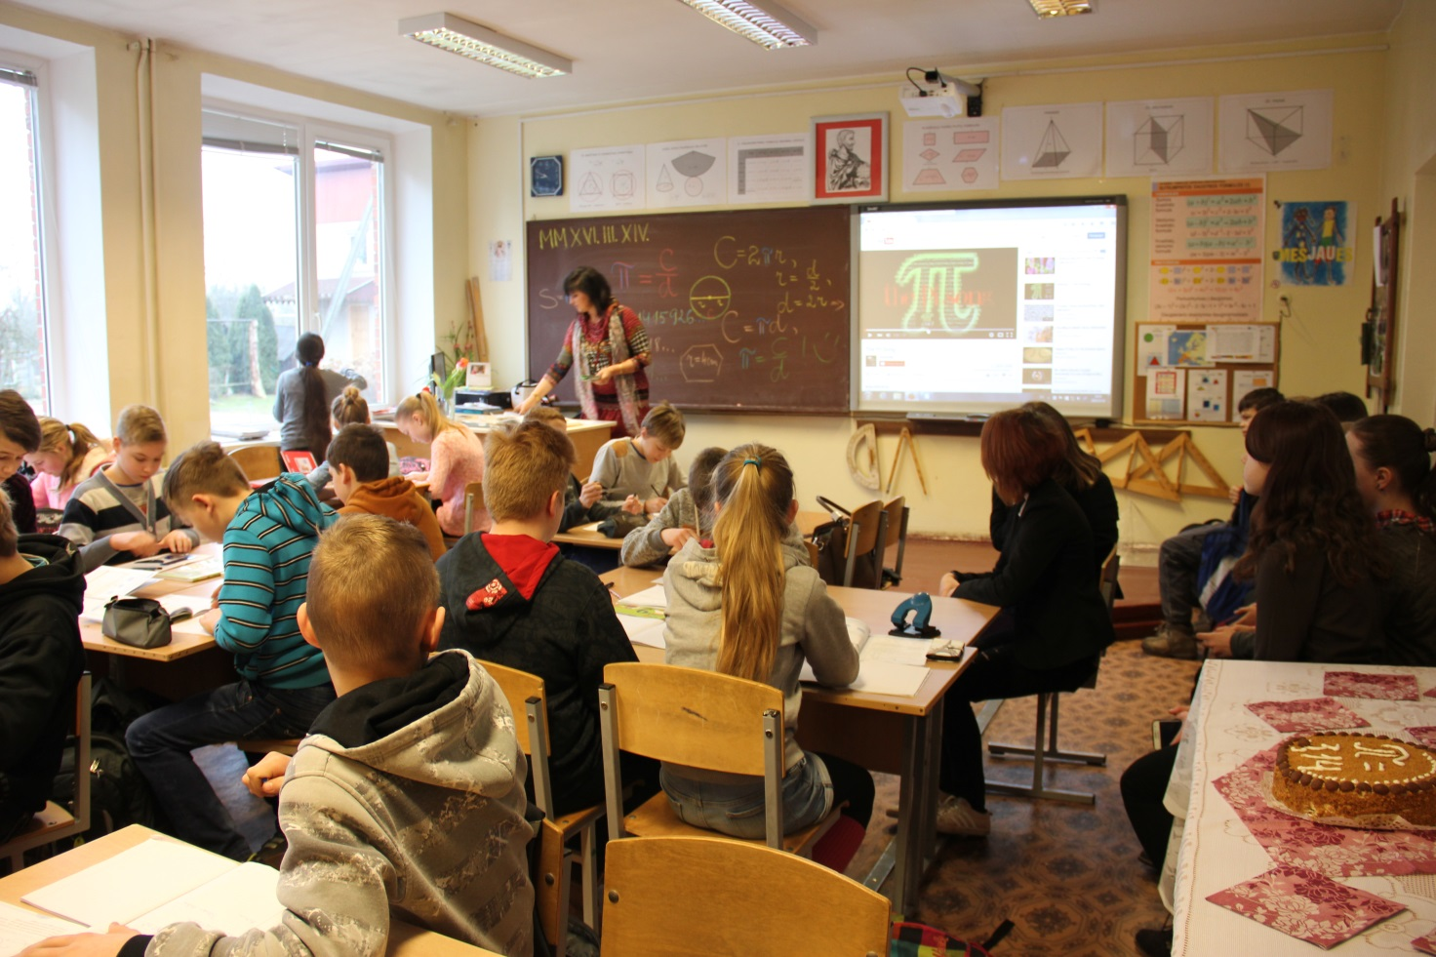
- The article about the Pi day was published in a local newspaper and on school website:http://www.lekeciai.sakiai.lm.lt/:

International Pi Day
Every year mathematicians all around the world celebrate the International Pi Day on 14th March and do funny tasks, play tricks and eat pies. Why pies? Because the English pronunciation of the word “pie” and the Greek letter Π is the same, mathematicians decided to celebrate this day in a funny and tasty way.
This popular commemoration of the surd was also celebrated by the team of young mathematicians from Lekeciaischool. They went to Griskabudis gymnasium and together with students of class 6 participated in the math lesson. During the lesson they learnt how to calculate the area and the length of a circle. Students listened to the history of the Π from ancient times and tried to find their date of birth, phone number or personal number in an infinite number sequence. According to the tradition students were given tasks to solve for 1 hour 59 minutes – that is the further sequence of Π numbers. We did not have enough time so we had to shorten our competition and finished it with eating confectionery and the cake decorated with Π.
The second part of the festival was at the Geology museum where everyone was interested in collections of fossils, stones and sand from all over the world. Students got to know about minerals, volcanic rocks, amber examples found in Lithuania. They also calculated and compared weight and sizes of minerals.
At the end of the festival students and teachers discussed about collaboration of schools and future plans.

APRIL, 2016
- Maths teachers organised the seminar for Maths teachers in Sakiai district.
(More information is available in Annex)
- The article about seminar was published on a local website http://www.gelgaudiskis.sakiai.lm.lt/index.php?start=4:
Conference for Mathematics Teachers in Gelgaudiskis
Information
April 15th, 2016
Gelgaudiskis is a small capital of culture this year. A lot of various events are held in it. One of them was devoted to mathematicians. On April 8th there was a conference for mathematicians of Sakiai district. The topic of the seminar was “News of Mathematics in a Modern School”. Participants of the event were current and former maths teachers as well as people interested in maths. The event took place in Gelgaudiskis Manor which was a perfect place for sightseeing and pleasant communication with colleagues.
40 mathematicians participated in the event. Two of the guests were the Doctor of Mathematics RomualdasKašuba from Vilnius University and his colleague and fan of mathematical rebuses PetrasVirbauskas. RomualdasKašuba, a former inhabitant of Gelgaudiskis, was delighted to share his knowledge and best practice with our teachers. The lecturers discussed about news of mathematics and their importance in life, interesting tasks, clarified the solutions of tasks.
Mathematics senior teacher RutaKrikstopaitiene from Lekeciai School read the report about the possibilities to teach mathematics creatively and presented the project “Active, Attractive and Interactive eU Mathematics”. Teachers from Sakiai district had a look at Internet websites made during the project and they were encouraged to use and to help to make websites.
After the seminar mathematicians discussed about impressions and talked to colleagues. Everyone was proud of the former teachers who left school long time ago but are still interested in mathematics. They also could meet their colleagues and friends.
- We organized the 2nd transnational meeting.

MAY, 2016
- Mathematical trip - lesson.(More information is available in Annex)
- Europe day. http://www.lekeciai.sakiai.lm.lt/
(Scenario and information is available in Annex)
EUROPE DAY - info
Students from Lekeciai School in Lithuania celebrated Europe Day on May 9th. They participated in a discussion about the importance of living in the European Union and being a European citizen. Students also took part in Europe Day Quiz and could test their knowledge of European Union. Students made posters with factfiles of European countries and presented them to other school students

- Teachers prepared information for the project’s newsletter.
- Creation and translation of lesson plans.

